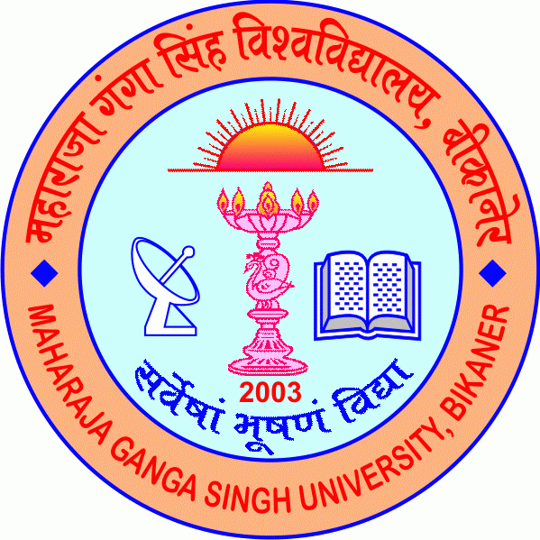
Maharaja Ganga Singh University
NH-15, Jaisalmer Road, Bikaner-334004
www.mgsubikaner.ac.in
Advertisement Empanelment (2025-26)
Applications are invited for empanelment of Guest Faculty for UG/PG programs in Drawing and Painting, Law and Zoology. Retired/faculty members in Colleges/Institutions/Universities or other qualified applicants may send their CV along with attested documents in support of their eligibility to the Registrar, Maharaja Ganga Singh University, N.H.-15, Jaisalmer Road, Bikaner-334004, Rajasthan latest by 23.10.2025. For details please visit: www.mgsubikaner.ac.in

Registrar

