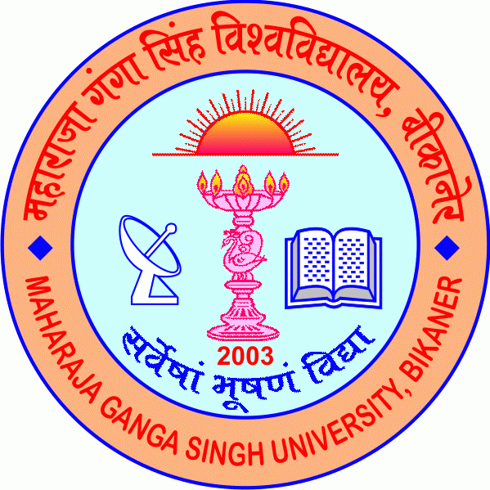
Ekgkjktk xaxk flag fo'ofo|ky;
Maharaja Ganga Singh University

Applications are invited for empanelment of Guest Faculty for the session 2025-26 in various Departments/Centres of Maharaja Ganga Singh University on purely per lecture basis. Details of Required Qualifications and Experience are :

Departments/  Centers/Programmes | Programmes/Courses | Required Qualifications | Specialization
Zoology | M.Sc. Zoology | As per UGC norms/ Retired faculty from Universities and Colleges/ Faculty teaching in other Colleges/Universities
Drawing and Painting | M.A. in Drawing and Painting | As per UGC norms/ Retired faculty from Universities and Colleges/ Faculty teaching in other Colleges/Universities
Law | Law, B.A.LL. B (5 Years), LLM, PG Diploma in Legal and Forensic Science | As per UGC norms/ Retired faculty from Universities and Colleges/ Faculty teaching in other Colleges/Universities

